COVER SHEET

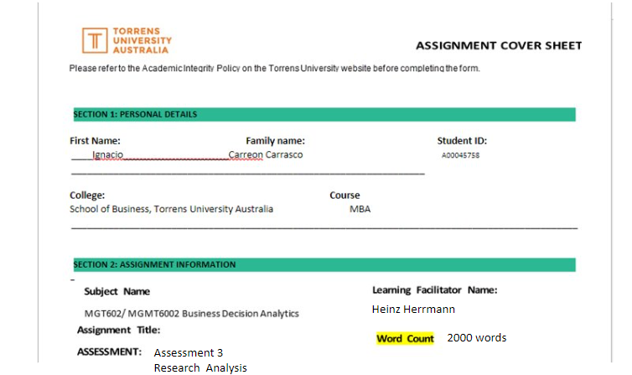

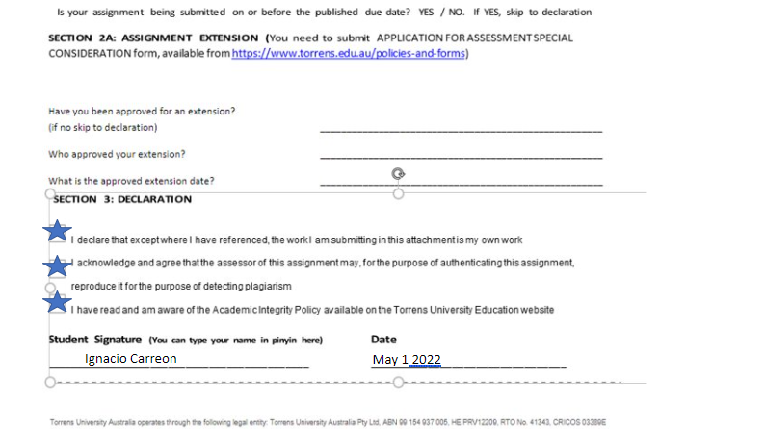

**EXECUTIVE SUMMARY**

This report presents us with different types of decisions that could have been carried out for the case of work of the financial institution of Citibanamex, a Mexican subsidiary of the American group Citigroup dedicated mainly to the commercialization of financial services.

The case shows us a true event that took place approximately 7 years ago in which the Regional Sales Manager of the Pension Funds area had to implement measures against different problems related to the improper handling of privileged information of the institution's clients.

Derived from the change and update of internal policies due to regulatory decisions of the corresponding Mexican authorities, as well as the digital transformation that was taking place at that time, more current information management policies had to be implemented that affected both users as to the collaborators.

For this work, different methods were analyzed that approached the subject in question and that describe the work method that was carried out in the organization at that time.

**TABLE OF CONTENTS**

Executive Summary.....................................................................................................................2

Introduction..................................................................................................................................4

Analysis and Evaluation...............................................................................................................5

Data visualization.......................................................................................................................14

Conclusion..................................................................................................................................15

References.................................................................................................................................16

Appendix......................................................................................................................................17

**INTRODUCTION**

This paper addresses different decision-making models applied to the case of the company Citibanamex, in which a Regional Sales Manager is forced to make strategic decisions in relation to the management of privileged information of customers.

During this paper we will talk about the rational model, bias and group decisions.

In the rational model, it will try to address the work case from the perspective of the Sales manager. An attempt will be made to reach a coherent solution using the methodology that characterizes it.

The exposed Bias correspond to those that are deduced the Sales manager could be influenced when making the pertinent decisions.

The group decisions section shows the type of philosophy and hierarchical structure of the company as well as the type of meetings held depending on the time, place and work team to which the collaborators were assigned.

The report is made up of an executive summary, an introduction, 3 decision-making models seen during the course, visualization of data corresponding to the industry in reference, conclusion, 10 references and an appendix that includes images of the branch where work during that period.

**ANALYSIS AND EVALUATION**

Background to the case

Citigroup is a global financial institution of American origin with different subsidiaries around the world that has different businesses, among which are: investment banking, consumer banking, insurance, pensions, among others.

The financial group has a subsidiary in Mexico (Citibanamex), my country of origin, which is currently in the process of being sold but which for approximately 20 years was key to banking operations in the North American region.

In Mexico, the institution has permission to operate as a bank and in turn has other subsidiaries dedicated to investment, pensions, consumer loans, business and asset management. For a year (2014-2015) I worked as a Sales Representative in the Pensions area, a position that required direct contact with the client and in-depth knowledge of the financial product to be offered.

During that time, a technological change was taking place both in the company and in the sector, since the regulatory entities of the pension funds required that each user have their updated data in the system, including biometric data such as digital signature, fingerprint and updated photography. This was a great challenge for the institution since the sales representatives did not have the necessary equipment to carry out their functions, which meant that a significant investment had to be made to acquire quality equipment that could be transported anywhere and that meet the necessary technical specifications.

With these new customer verification protocols and with the new identification requirements implemented, there began to be a considerable increase in the amount of confidential information that we as sales agents had to handle, since now around 3 documents had to be collected additional to those originally held, and this information required special treatment because it was highly confidential data.

As time went by, there were incidents related to the handling of personal data of clients, among these I could describe the following:

* Adjudication of clients by sales representatives who did not work the sale. (Customer theft)
* Loss of confidential information
* Client complaints about marketing without authorization (cell phone calls)
* Registration of services not related to our functions as a pension fund.
* Sale of customer data (customer ID’s) to other institutions.

All these incidents could have been handled in a better way with a clear and detailed policy on the handling of information, as well as with the application of security filters that made it more difficult to steal privileged information.

With the previous example, it can be said that the institution, the employees and the manager on duty made mistakes regarding the management of the information, which would cause a breach of the ethics of confidentiality towards the institution's clients.

Rational Model

Being the opposite of intuitive decision making, rational model of decision making is a model where individuals use facts and information, analysis, and a step-by-step procedure to come to a decision. The rational model of decision making is a more advanced type of decision-making model. Uzonwanne, F. C. (2016)

Managers of large organizations like financial institutions must deal daily with decisions that keep the business running smoothly. These decisions are key to good staff management and to achieving a friendlier environment within the work environment, however on many occasions, they can cause misunderstandings or may not please everyone involved. The management of customer information is a key aspect in the operation of the financial institution, so problems or complaints related to this issue must be a priority when knowing what is happening.

The possible procedure to follow to solve the problems related to the management of private information according to the rational model is exemplified below.

**Identify the problem**

Lack of customer data confidentiality ethics

Improper handling of personal documents (address ID, etc.

Outdated personal data management policy

Absence of sanctions or punishments.

Ineffective security locks against information protection

**Decision Criteria**

The privacy and secure protection of customer information is a fundamental part of the business, so it is vital to identify possible actions that effectively protect this resource. It is known that due to the new regulatory requirements, sensitive information related to the client must be collected, so improving and updating the data management policy is important to comply with the regulations. Some employees are relatively new to the institution, so reinforcing knowledge related to this area is vital. Technology is of great help for the daily problems we face, so developing a solution that allows us to safeguard and protect data in a lesser way will help with the objectives set.

**Weighting**

|  |  |
| --- | --- |
| Criteria | Weight 1 to 5 |
| Lack of customer data confidentiality ethics | **5** |
| Improper handling of personal documents (address ID, etc.) | **5** |
| Outdated personal data management policy | **3** |
| Absence of sanctions or punishments. | **4** |
| Ineffective security locks against information protection | **4** |

**Potential alternatives**

1.- Retraining and online certification in data management

2.- Internal complaint and reporting policy

3.- Personal keys for devices

4.- Application of more severe fines

5.- Change in internal data collection processes

**Analyzing alternatives**

1.- Retraining and online certification in data management

A retraining of the labor force can be positive to reinforce the knowledge of the good practices that must be followed in the organization, although it may take a little time for the collaborators.

2.- Internal complaint and reporting policy

Reinforcing the culture of reporting within the organization can go a long way in detecting problems faster or before they happen.

3.- Strenghten passwords on devices

Encourage the use of more secure passwords

4.- Application of more severe fines

Establish harsher sanctions (financial and criminal) for employees who share or misuse information

5.- Change in internal data collection processes

Create security filters so that agents cannot extract information so easily

**Select Solutions**

Retraining and certification

Internal policy

More severe penalties

**Implement Decision**

A multidisciplinary decision that involves updating the policies for managing privileged information as well as online retraining of the workforce on the subject and increasing sanctions (financial and legal) for individuals who violate the code.

BIAS

A bias is a prejudice or a propensity to make decisions while already being influenced by an underlying belief. Chira, I., Adams, M., & Thornton, B. (2008). Behavioral bias within the decision-making process.

It is difficult to know a person thoroughly, especially if you do not have such close contact with them on a day-to-day basis. However, as an employee, I can deduce that the Sales Manager of the case in question presented certain Bias characteristics of any person who I describe below.

Authority Bias. -

It was very clear and obvious that this type of bias was predominant in the office. Middle managers commonly tried to impress or strike up friendly conversations with bosses to try to gain some sympathy for them.

Confirmation Bias. -

It refers usually to unwitting selectivity in the acquisition and use of evidence. Nickerson, R. S. (1998).

It can be concluded that my manager was a difficult person to change his mind, he was generally very well informed, however the information he had was specific to his general ideals, something that most people do, however I could say that he tended to take advantage of that in order to be the one who wins in the conversation.

Loss aversion Bias

Normally, hierarchical positions of power tend to be competitive within the labor aspect, so the feeling of defeat is not well received once it occurs. Because I was in the place long enough, I could tell that our manager was passionate about his work and hated to lose or not go as expected.

As Kahneman mentions one implication of loss aversion is that individuals have a strong tendency to remain at the status quo, because the disadvantages of leaving it loom larger than advantages. Kahneman, D., Knetsch, J. L., & Thaler, R. H. (1991).

Employees/Manager

Status Quo Bias

During the time of digital transformation in the company, there was an atmosphere of uncertainty among employees. The bosses themselves sometimes did not have the answers that we as employees needed to be calmer. You didn't have to be very intelligent to realize that no one wanted significant changes in the way of working, however, these were changes that were needed and that were ordered by the regulatory agents of financial institutions.

Research has shown that there is a human tendency to emphasize the importance of recent experience in estimating future events Caughey, D., Berinsky, A. J., Chatfield, S., Hartman, E., Schickler, E., & Sekhon, J. S. (2020).

As can be seen, the work environment in the Citibanamex office was basically like that of any company, at least in Mexico, it can be concluded that some excesses in this type of attitude could lead to the omission of rules or important events that would have an impact later. in the operation of the organization.

.

Group decisions

The Citibanamex group in Mexico City was divided into regions throughout the Metropolitan area. Due to its size, there were about 6 geographical zones within the same city that were led by Area Managers.

My boss (Regional Manager) was responsible for a specific region in Mexico City that consisted of around 10 branches in which there were an average of 2 sales agents depending on the size of the branch.

The part in charge of the pension fund and the work team of each branch were different, so on repeated occasions there were differences in terms of schedules between these two teams.

As pension agents, we reported directly to our Regional Pension Manager, however, we worked every day with the branch team, which in turn had department heads and an independent manager from the financial institution.

As Murray, P., Poole, D., & Jones mention, groups rely on the formal structure of the organisation to provide meaning and purpose, most of them are merely the formally constructed mechanisms through which organisations pursue their goals. Murray, P., Poole, D., & Jones, G. (2006). In the case of Citibanamex, each one of the work groups was formed according to the policies of the organization and with well-established objectives and purposes which could be read and visualized in each one of the branches.

The number of meetings, their approximate duration and estimated dates are described below.

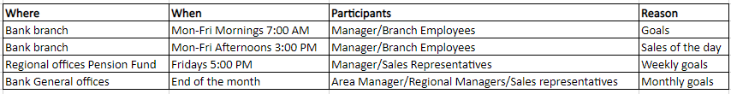

Table 1 Schedules

**DATA VISUALIZATION**

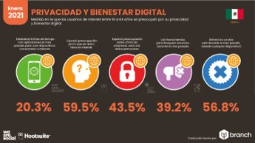

Privacy and digital well-being source :Hootsuite

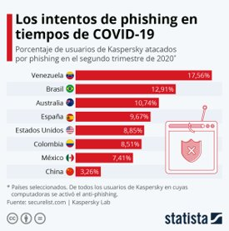

Number of phishing attempts in the Latin American region compared to other countries.

www.statista.com

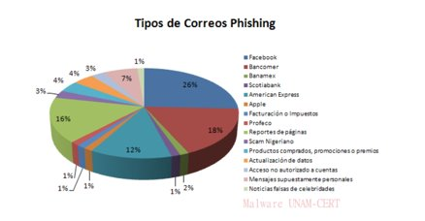

Phishing to Mexican institutions (channels) Source UNAM

**CONCLUSION**

This work focused on applying decision-making techniques to a true case witnessed a few years ago in a franchise of a financial institution with international recognition. An example was presented where a problem arose with the handling of private customer data. of the institution and how the lack of a robust privacy protection policy can harm companies of all sizes in different ways.

The rational method was applied to be able to try to give a probable solution to the problem raised, in this way different points were developed from the identification of the problem to the implementation of a solution according to the needs of the institution.

Different biases were described in the work in which it tries to explain the possible scenarios in which the protagonist of the story's Sales Manager was involved.

Group decisions was approached in such a way that the work culture in the company was described with respect to the decisions that were made on a daily basis and depending on the assigned group and the time of day in which we found ourselves.

It can be concluded that decision making falls mainly on hierarchical figures within an organization. This is where the most important decisions are made, so having the most accurate knowledge on how to best approach it is a competitive advantage in the labor field that gives certainty to employees and that most of the time is reflected on productivity in a positive way.

REFERENCES

Uzonwanne, F. C. (2016). Rational model of decision making. *Global encyclopedia of public administration, public policy, and governance. Springer International. https:/doi. org/10.1007/978-3-319-31816-5_2474-1*.

Chira, I., Adams, M., & Thornton, B. (2008). Behavioral bias within the decision making process. Page 2 pp 2

Caughey, D., Berinsky, A. J., Chatfield, S., Hartman, E., Schickler, E., & Sekhon, J. S. (2020). *Target Estimation and Adjustment Weighting for Survey Nonresponse and Sampling Bias*. Cambridge University Press.

Nickerson, R. S. (1998). Confirmation bias: A ubiquitous phenomenon in many guises. *Review of general psychology*, *2*(2), 175-220.page 1 pp 5

Kahneman, D., Knetsch, J. L., & Thaler, R. H. (1991). Anomalies: The endowment effect, loss aversion, and status quo bias. *Journal of Economic perspectives*, *5*(1), 193-206.page 5 pp 3

Murray, P., Poole, D., & Jones, G. (2006). [*Contemporary Issues in Management and Organisational Behaviour.*](https://torrens.blackboard.com/bbcswebdav/pid-10421487-dt-content-rid-33766432_1/institution/Chifley%20School%20of%20Management/MBA%20Revision/MGT602/3.%20Resources/Module%203/Chapter%2012_Part%201.pdf) Routledge: Australia. Chapter 12 Managing high performance teams. Page 12 pp 1

**APPENDIX**

Citibanamex regional offices Mexico city



<https://www.google.com/maps/@19.3203164,-99.1387393,3a,75y,256.83h,93.77t/data=!3m6!1e1!3m4!1sRUdudJKWFtd5UeKqAh3rOw!2e0!7i16384!8i8192>

Biometrics Law Pension Funds

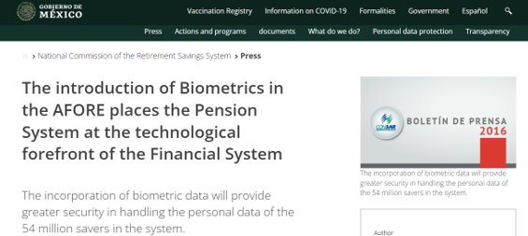

https://www.gob.mx/consar/prensa/la-introduccion-de-biometricos-en-las-afore-coloca-al-sistema-de-pensiones-a-la-vanguardia-tecnologica-del-sistema-financiero-31831